AFYA BORA CONSORTIUM GLOBAL HEALTH LEADERSHIP FELLOWSHIP PROGRAM
GLOBAL HEALTH POLICY AND GOVERNANCE

Instructors: Kristen Hosey, and Alice Kayongo
Collaborating Instructors (unable to attend): Rochelle Dicker and Yuka Manabe
Kampala, Uganda: June 21-June 24, 2016
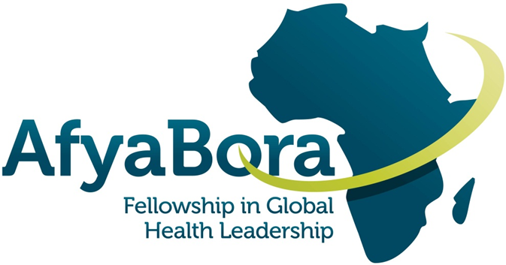

AFYA BORA CONSORTIUM

GLOBAL HEALTH POLICY AND GOVERNANCE

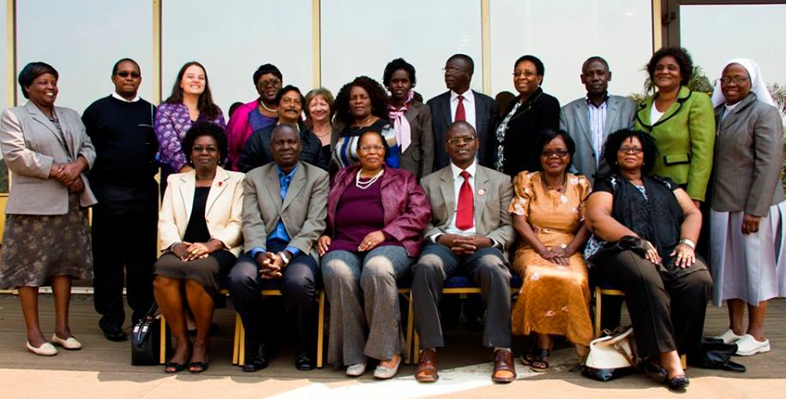
ECSACON Leaders, Afya Bora Fellows and Site Mentors – Harare, Zimbabwe 2014

Module Instructors

Dr. Rochelle Dicker Dr. Kristen N. Hosey
Email: Rochelle.Dicker@ucsf.edu Email: khosey@uw.edu

Alice Kayongo Dr. Yuka Manabe
Email: alkayongo@gmail.com Email: ymanabe@jhmi.edu

Guide for Fellows and Instructors

Table of Contents

BACKGROUND/CONTEXT 4
Overall Learning Goals 4
MODULE SCHEDULE: Global Health Policy and Governance 7
Day 1: 8
DAY 2: 10
DAY 3: 12
DAY 4: 13
Appendix 1: Health Policy Brief 14

Appendix 2: References - separate attachment (located in your dropbox folder)
Appendix 3: SDG's Opinion Piece - separate attachment (located in your dropbox folder)

Global Health Policy and Governance Module
Afya Bora Fellowship Agenda

BACKGROUND/CONTEXT

What drives health and healthcare inequalities? What are the underlying policies that help determine these inequalities? Who has the power to change these inequalities? Why are some health issues prioritized over others? Each of these critical questions maybe considered through the lens of health policy. This module will provide an introduction to health policy through a series of lectures by various experts in the field, case studies, field visits and a student-produced presentation. The course will cover some of the basics of health policy including investigations of burden of disease, health financing, global health actors and health workforce. It will also examine how other disciplines, including the law and economics, interact with health to create governing health policy.

Overall Learning Goals

- Define global health policy and the special circumstances that may influence health policy in low- and middle-income countries
- Identify the major actors in global health policy and describe their influence on global health policy and relation to each other
- Become familiar with concepts around how global health policy is made
- Utilize their concepts to analyze specific health policies
- Critically examine key issues in global health policy

Module Assignment

Fellows will be engaged and dialogue with the guest speakers and will be active participants in the module. One ongoing activity throughout the week will be the development and presentation of a policy brief.

Group Work: Policy Brief Exercise

Overview: The week will provide introductory exposure to components of policy development and implementation. In this exercise, fellows will be provided with the opportunity to explore the nuances of policy development and effective presentation to policy-makers. Groups will work together during the week to develop a cogent policy plan and present this plan in a role-play fashion to experts.

Goals:
- Work in a team-oriented environment on a single topic with the focus on a single health policy issue to be presented to experts in the field
- Understand how to construct a policy brief
- Capacity to understand the assortment of priorities amongst all stakeholders in the process of policy development including front-line workers, Ministers and citizens
- Communicate verbally various positions and points of debate in an organized, professional, and comprehensive fashion

Conduct: Fellows will be placed into groups of four. On day one, they will be tasked to come up with a subject that they will advocate for. They will brainstorm on the following:
- Subject matter-What are they most passionate about? What constitutes a real public health need? What background information from the course can they incorporate in their preparation?
- Game plan-there will need to be the development of a strategic plan. What has been done on the subject? What still is necessary and what are the priorities? What are the financial implications? What is the landscape of the issue? Set up for the strategic planning that needs to occur the rest of the week.

On the morning of Day 2, facilitators should be provided with the topics each team selected. Throughout the day facilitators will go over subject matter with the teams to assess feasibility and make suggestions as to alternative subject matter if appropriate.

Day 2 and 3: Create the brief and explore the potential positions of other stakeholders.
- Based on thorough landscaping and the importance of the issue, the team will put together a comprehensive presentation for dignitaries to consider. Aspects of the argument will include financial ramifications, affect on population health if proposal is adopted or not adopted, feasibility and plan for implementation.
- The team will also explore the potential angles and priorities of other stakeholders. This includes: Police, Ministers of Finance and Health, community leaders, scientists, and individuals effected by the issue. This is critical for making a strong argument AND members of the team should be ready to PLAY these roles.
- The day prior to presentation (afternoon of Day 3), individuals on the team will draw straws as to what “role” they will play. Facilitators will have already mentioned to the group, based on the subject matter, who the stakeholders might be. This may include:
  - Frontline workers - This person will likely present the case
  - Minister of Finance - This person will focus on the monetary effect of implementation of the proposal
  - Minister of Health - This person will focus on the level of priority this issue seems to have (based on the argument presented and other issues in the country) on population health
  - A citizen directly affected by this issue - They will serve as an advocate, and give heart-felt testimony regarding the issue and how it has effected their lives
  - Hospital Administrator - Similar role as a combination of Finance and Health Ministers
  - A scientist with data to support the cause - This person will present, when appropriate, studies that have been conducted to make the argument for advocacy stronger
  - WHO representative - This person will provide a vantage point of overall goals for health care worldwide priority items. They will either end up advocating for the presenter, or asking tough questions along with the Ministers and the Hospital Admin person.

All of these individuals are suggestions except the frontline worker is the key person who will be presenting the issue at hand. Other potential stakeholders may be possible based on the subject chosen.

Evaluation: Dr. Alex Coutinho, Asia Russell and other facilitators involved in the weeklong module will provide evaluation of the policy brief delivered on the last day. Feedback will be given based upon performance of each individual, and how well they understood their role realistically. Weight will be particularly given towards the strength of the frontline individual’s presentation given that this reflects the culmination of the work of the group during the week.

Appendix 1 has more information on how to write a policy brief, but note that this will be an oral presentation. No PowerPoint presentation will be available. However, your group may provide a short handout to evaluators.

MODULE SCHEDULE: Global Health Policy and Governance
 | Tuesday June 21 | Wednesday June 22 | Thursday June 23 | Friday June 24
8:30am | INTRO LECTURE:  Dr. Kristen Hosey  “Overview of Universal Health Coverage” | LECTURE: Prof. Severine Rugumamu  "Political Economy of Aid" | LECTURE: Dr. Zahara Nampewo  “Intellectual Property” | LECTURE: Dr. Alex Coutinho  “Leadership and Policy”
10:15 | Tea | Tea | Tea | Tea
10:45 | LECTURE:  Alice Kayongo  “Global Health Policy Actors” | PANEL: “Health Financing”  Keynote: Mark Tumwime  Panel: civil society; media; government representatives | LECTURE: Jessica Oluoch  “Health and Law” | Fellow PRESENTATIONS (10 minutes or less)
Noon | LECTURE and DISCUSSION: Alice Kayongo  “How to Frame a Policy Brief” | Q&A with guest speakers about health financing | GROUPWORK: Ethics, health and law scenarios | Winning Group Announced (before lunch)
1:15pm | Lunch | Lunch | Lunch | Lunch
2:15pm | LECTURE: Dr. Margaret Mungherera  “Unions and the Role of Healthcare Providers in Advocacy” | DISCUSSION: Dr. Kristen N. Hosey  “Making the case for  Sustainable Development Goals” | DISCUSSION: Dr. Kristen N. Hosey  “Research and Policy” | Wrap-Up and Ethos of ABC and your Leadership Pathway
3:30pm | Split into groups (2-3) to decide topics | Groups Work on Policy Brief | Groups Work on Policy Brief | Complete Evaluation of Policy Module

Day 1:

Lecture 1.1: Introduction Lecture

Global Health Workforce Universal Healthcare Coverage
Dr. Kristen N. Hosey, University of Washington School of Nursing

In this session, course directors and participants will introduce themselves. This session will then launch into a discussion about universal healthcare coverage. There is a global shortage of skilled health professionals. This talk will outline the etiologies of this critical issue as well as examine several ways to address the problem and fill the global gap.

By the end of this session, fellows will:
- Be introduced to the course and know the course objectives
- Explain several factors driving the global health workforce shortage
- Analyze potential solutions or ways to address this issue.

Lecture 1.2: Global Health Actors
Alice Kayongo, AIDS Healthcare Foundation

Key players influence health policy on the global, regional and national level. This session will review some of the main global health actors and their roles in setting health policy.

By the end of this session, fellows will:
- Recognize the role and reach of key actors including the WHO, the Global Fund to Fight AIDS, TB and Malaria, the Gates Foundation among others
- Identify several ways to access these global players

Lecture and Discussion 1.3: How to Frame a Policy Brief
Alice Kayongo, AIDS Healthcare Foundation

A policy brief is a tool used for communicating to government policymakers on recommendations for formulating or influencing policy. This session will provide an overview of how to write a policy brief and how to present your policy brief to government officials to influence global health policy.

By the end of this session, fellows will:
- Recognize the role of a policy brief
- Answer the question, “What do I see in global health that I feel the most passionate about improving over the next 5 years?”
- Walk through an example of a policy brief and how to present it to policymakers to influence change.

Lecture 1.3: Unions and the Role of Healthcare Providers in Advocacy
Dr. Margaret Mungherera, Uganda Medical Association

This session will discuss the role of healthcare workers in advocacy. A representative from the Ugandan Medical Association will discuss key issues when advocating and acting as mediator between health professions and the government.

By the end of this session, fellows will:
- Recognize allies and how to work with them to advocate for the profession
- Understand the role of the union in mediating between governments and medical fraternities.

Group Work 1: Divide into groups of 4 and identify a policy brief topic. Please email facilitators your topics or provide them your topic information before the module starts (i.e., before 0830) on Day 2.

DAY 2:

Lecture 2.1: Political Economy of Aid
Prof Severine Rugumamu, University of Dar es Salaam

This session will highlight basics in understanding the conditions that shape population health and health service development within the macro economic and political contexts. The main objective is to develop background knowledge and conceptual tools for analyzing the political and economic structures and dynamics at local, national and global levels which frame the social and environmental determinants of health and which frame health policy and funding directions.

By the end of the session, fellows will:
- Understand what is wrong with the global health picture – motivations and constraints of both donors and recipients.
- Explain what we need to do in our different capacities.
- Explain what donors need to do.

Lecture 2.2: Health Financing Panel
Keynote: Mark Tumwime, Centers for Disease Control and Prevention

Panelists will include representatives from civil society, government and the media, including:
- Bharam Namanya – Community Health Alliance Uganda
- Hilary Bainemigisha – Media representative
- Tom Aliti - Commissioner for Health Planning in the MOH

This session will focus on how financial resources are generated, allocated and used in health systems. There will be a keynote speaker followed by a panel of representatives from civil society, media and government.

By the end of the session, fellows will;
- Understand how and where to raise sufficient funds for health
- Understand how to overcome financial barriers that exclude majority of the poor from accessing health services
- Explain how to provide an equitable and efficient mix of health services

Group Work 2.1: Health Financing

During this session fellows will break into groups and review their health policy brief and how health financing plays a role in their presentation. They will utilize the guest speakers to answer any questions they may have about their topics in order to better prepare them for their presentation on Friday. Consider the following:
- How is your topic affected by health financing?
- What actors play a role in your health policy? What are their different views on health financing? How might each actor approach your topic differently financially?

Discussion: Making the Case for the Sustainable Development Goals
Dr. Kristen N. Hosey, University of Washington School of Nursing

In September, 2015 countries adopted a set of 17 sustainable development goals focused on ending poverty, protecting the planet and ensuring prosperity for all…but are these goals too far reaching, or even obtainable at all?

By the end of the session, fellows will:
- Be introduced to the sustainable development goals (SDG’s)
- Discuss their own opinions of what the SDG’s mean to them and their future role as a global health leader.

Group Work 2.2: Fellows will work on their policy brief and presentations.

DAY 3:

Lecture 3.1: Intellectual Property
Dr. Zahara Nampewo, Makerere University School of Law

What do intellectual property rights mean, and what does it mean to global health leaders? This session will highlight the importance of intellectual property and ways to avoid infringing on these rights.

By the end of the session fellows will”
- Define intellectual property
- Differentiate between a patent and copy write
- Understand how these rights are important for being a leader in global health

Lecture 3.2: Health Policy and the Law
Jessica Oluoch, Kenya Ethical and Legal Issues Network (KELIN)

How can legal precedent be used to improve health care? What do treaties that include such provisions as the right to health mean for the ability to provide adequate quality care for all?

By the end of this session, fellows will:
- Become familiar with several examples of how legal precedent can further health for marginalized populations
- Understand how lawyers and legal organizations and health professionals can work together to create beneficial health policy

Group Work 3.1: Fellows will review case studies from KELIN with Jessica Oluoch and consider how these scenarios are at the intersection of health, ethics and policy. Reflect on how you would handle a similar situation in your own practice.

Discussion: Research and Policy
Dr. Kristen N. Hosey, University of Washington School of Nursing

There is a lag between what evidence and research shows to be effective and health policy change and enforcement. This discussion will ask questions about current evidence-based practice fellows are engaged in, and how to begin to communicate research findings in a way that can influence policy in order to shorten the gap from research to practice.

Group Work 3.2: Fellows will draw their actors for the final presentation and complete their preparation of the final policy presentations.

DAY 4:

Lecture 4.1: Leadership and Policy
Dr. Alex Coutinho, Infectious Disease Institute

Leadership in policy is key in motivating stakeholders and policy makers to implement change. You as a global health leader can influence policy, whether this is through leading by example or empowering, motivating, and inspiring others. Fellows will have the opportunity to hear from Dr. Coutinho who is a physician, academic and public health advocate.

By the end of the session fellows will:
- Learn from a physician who is also an experienced and successful leader in global health
- Reflect on their own leadership style and how they can impact policy

Fellow Presentations

During the first day, the class will divide into groups to prepare for fellow presentations at the end of the week. In these presentations, fellows will be able to demonstrate their analysis of health policy issue and present the potential viewpoints of various key stakeholders. Each group will develop a policy brief on a topic of their choosing, and will be able to defend this topic from the viewpoints they selected.

Dr. Coutinho and Asia Russell will announce the winning group and a prize will be awarded.

Discussion: Wrap-Up and Ethos of Afya Bora and your Leadership Pathway
Dr. Kristen N. Hosey, University of Washington School of Nursing

This discussion will serve as a wrap-up of the global health policy module.

By the end of the session fellows will:
- Articulate one policy issue they wish to change in the next 5-10 years and how they might do it
- Provide feedback on what they learned this week, and what policy areas they would have liked more information about.
- Consider how they can stay connected to impact change in the region through South-South collaboration.

M&E Specialist will distribute the anonymous evaluation of the Policy Module following this discussion. Please fill out so we can improve upon this module for next year!

Appendix 1: Health Policy Brief

Health policy briefs are short documents that present a clear, accessible overview of timely and important health policy topics or research findings and recommendations to a particular audience. Writing of a policy brief must be informed by extensive research, deep analysis and synthesis of both primary and secondary sources of information. In general, it should be a stand-alone document that is focused on a single topic. For this exercise, plan on writing no more than 2-4 pages. Often, policy briefs are written to be persuasive to a particular audience. For this reason, we are asking that you consider each issue from the point of view of policymakers, service providers and community members.

Executive Summary:
Consider a text box that gives snapshot information of the key recommendations or most effective evidence.
- Keep each point short—the detail is given in the body of the brief
- Each point should encourage the reader to read on
Distill the essence of the brief and provide a 1-paragraph overview for the busy reader. Ensure there is a sentence indicating the audience for whom the brief is intended. Pull the reader in so they are encouraged to read further. This should be written at the end (like the abstract of a paper) and summarize your main recommendation points in the more detailed sections to follow.

Introduction:
What is the central issue being addressed? Why is it significant? What is the urgency? State the problem or objective – you could phrase it as a question for which a decision must be made.

What is the relevant background? Include data whenever possible to highlight the problem. Be sure to include only essential facts that the decision maker needs to know.

Relevant research or if this is a brief for a particular study: present the objectives, overview of the findings, and conclusions

Summary of approaches and results:
What is the proposal? If this is a research policy brief, summarize the facts and interpret the results in an ‘easy to understand manner’, excluding all research and scientific jargon – remember the decision maker is most cases is neither a researcher nor a scientist and yet they must clearly understand what you are communicating.

Describe what has been piloted, researched or implemented (how the study was conducted, who conducted the study, where the study was conducted and methodology) and the outcome (what did we learn?).
Your interpretation, analysis, and synthesis: What are the issues? What is the debate? Highlight benefits, opportunities.

Implications: Include both what could happen and what should happen. The implications must be supported in the sections above and flow logically from what has already been presented. Depending on your audience, you may want to soft-pedal this section so that readers can draw their own conclusions.

Pre-existing policies and guidelines: Summarize what has ever been done about your research topic, especially if it is not the first of its kind. This helps inform the reader of policy options that have already been pursued, if any. The absence of no action may be a policy decision in itself that you may want to challenge in your recommendations.

Recommendations: What should happen on the basis of your interpretation of the implications of the background and data provided. What is next? Focus on relevance (to the audience), credibility on the basis of what was presented and feasible for the setting. Please sieve out and provide the main possible courses of action or inaction. Please limit these to a feasible number and avoid overwhelming the policy maker with so many options. The end result may be total inaction.

Concluding paragraph

Resources: (provided)

Authors: (state who wrote, constructed and contributed to the brief)
Finally, think about formatting. Make bolded titles and break up the text for reader interest and ease of use. Consider using sidebars to hook the reader and should be short, descriptive, stimulating and focused on action. Callouts where sentences or sentence fragments or quotes are printed in larger font and placed in the margins or in a box. Bulleted list of <5-7 items can be considered if thoughts are multi-part of complex. Charts, photos, graphics make visual interest.
Check your work. Make sure you have completed the following: proofread, edit, and spell check. Does a message clearly stand out? Don’t use too many statistics. Is it persuasive?

PS: Please remember that in writing this policy brief, you want to win a policy issue in line with what your findings were. Be succinct, specific, and persuasive in your presentation. You may not want to have your policy brief shelved just like any other.

NOTE: There is an example of a bad policy brief and a good policy brief in your dropbox folder.

 | Policy makers | Community members | Service Providers
What is the aim of the policy brief?
What do you know about the audience?
What is the best hook for the audience?
What background information is necessary?
What data will you include? How will you present it?
What policy options are there (if appropriate)?
What recommendations will you make?
Can you come up with a catchy title?

